APRIL-MAY-JUNE 2026 NEWSLETTER
 | INDIGO PINES CONDOMINIUMS
Office: 386-274-4039  Hours: Mon.-Fri., 10am-3pm (closed for lunch 12pm-1pm) |  |  |  |  | indigopinescondos@gmail.com  Website: indigopinescondos.org
  Did you see Artemis II space shuttle launch on Wednesday night? What a spectacular sight. We are very fortunate to be able to see this history making event.  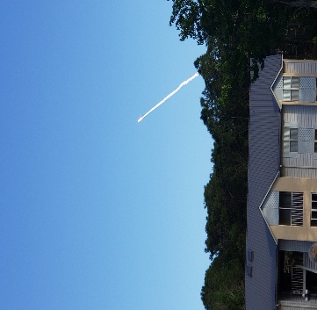      Thank you to Terry Brannan, Debbie Klink, Kelly Bailey, Duane Messier, Sandra Lloyd & James. All your hard work around our community is much appreciated; freshly painted lamp posts (love how they match our roofs), new white vinyl post sleeves, for painting the building number/unit signs, And a special thank you to Duane for the added touch of reflector lights on the top of our building number signs.  ANNUAL COMMUNITY YARD SALE  Our community yard sale on 3/27 & 28 was a bit disappointing as we usually have a minimum of 10 families involved. The sign up sheet indicated we would have 12+ but many cancelled, no-showed or set-up late thus our presence when pulling into the complex was sparse and not very exciting. Thank you to those of you who did participate. It takes a lot of work to make the event happen. We will keep you posted should be decide to arrange this again in the future but looking doubtful.    COMMUNITY GAME NIGHT  Our community game night has been a great success and tons of fun. We are planning to continue it once a month in the clubhouse, the 3rd Thursday of the month, 6pm-8pm. Game for the month will continue to be LEFT, RIGHT, CENTER. It’s ok if you don’t know how to play, we will teach you. Open to everyone; owners and renters (sorry, adults only). We will provide snacks, bring your own beverages.  SEE YOU ON THURSDAYS, 4/16, 5/21 & 6/18  RECENTLY OPENED – NEW TO THE AREA  Bronx House Pizza  Tomoka Town Center, offering full bar and dine-in seating for up to 100ppl  Dutch Bros Coffee  1972 LPGA Blvd. (north side of the road, between Dunkin Donuts and BoJangles)  Open 7 days a week starting at 5am, drive-thru available  COMING SOON  Take 5 Oil Change  1962 LPGA Blvd. (south side of the road, across the street from BoJangles)  DISCOUNT COUPONS AVAILABLE ON-LINE  F&D Cantana  A multi-leve venue with a rooftop bar and speakeasy tequila bar, is due to open in the fall, located in One Daytona  FOOD TRUCKS  The apartment complex arranges food trucks throughout the month. I personally have enjoyed not having to think about dinner and have found most of the food is really good. We do our best to post notice of who, when and what vendors are coming, posted by our mailboxes.    “When you’re young, you play with them….. When you’re older, you lose them!”    Do you have something to share (news, items or services for sale, recipes, fun tidbits) for our next newsletter? Please contact me through the IPCA email address or feel free to stop in, let’s chat. |  |  |  |   Board of Directors:  PRESIDENT: Terry Brannan  tbrannan2@cfl.rr.com  VICE PRESIDENT: Debbie Klink  dak1354@outlook.com  TREASURER: Jane DePasquale  jmdepasquale8@gmail.com  SECRETARY: Kelly Bailey  kelly_jax@yahoo.com  DIRECTOR : Duane Messier  duanemessier@yahoo.com  Thank you for your service, we appreciate your time.  ANNUAL MEETING:  Our annual meeting will be held towards the end of May at which time the new budget will be discussed. Residents will be notified far in advance of the exact date.  FOUNTAIN LIGHTS UPDATE:  If you haven’t noticed by now, please take a moment to observe our beautiful fountain lights.  PARKING TAGS:  The new parking tags went into effect on March 1st, however, we have noticed there are some vehicles still utilizing the old tags or without tags at all. If you have not yet picked up your parking tags, please do so immediately or your vehicle is at risk to be towed. If you are unable to visit the office during normal business hours, send us an email and we will make arrangements to meet your schedule.  “BE ALIVE, BE STRONG,  BE HAPPY…… JUST BE”  REMINDER    Indigo Pines Condos has a FaceBook page. If you are not part of our social media family, please feel free to request in joining us. There might be something fun listed or important news you should be aware of. As well, you are able to post on the sight, with permission from one of our administrators.    Did you know our Spectrum TV plan include access to top apps at no extra cost, including Max (formerly HBO Max) Basic with Ads, Disney+, Hulu, ESPN Unlimited, Paramount+ Essential, Peacock Premium with Ads, FOX One, AMC+ with Ads, and ViX Premium with Ads.  If you are not yet enjoying these channels, please contact Spectrum Customer Service for assistance. If you have not done so already, you will be required to switch out your old cable boxes to the new XUMO boxes and remotes.  CUTE DOG JOKES    -What do you call a dog that can do magic? A labracadabrador.  -What do you call a dog that can fly?  A poodlecopter.  -What do you call a dog that is always eating? A chow hound.  -What do you call a dog that can read minds? A psychic spaniel.  -What do dogs eat at the movies?  Pupcorn.  -What do you call dogs that like to play in the snow? Slush puppies.  -What dog like to live in big cities?  A New Yorkie.  -What did the Dalmation say after dinner? That hit the spot.  -What do dogs have in common with phones? They have collar ID.  -How can you tell if a dog is lazy?  It only chases parked cars.  -What kind of dog does Dracula have?  A bloodhound. |  |  |   DATES TO REMEMBER:  4/15 Tax Season-Deadline to file  4/16 COMMUNITY GAME NIGHT  4/22 Earth Day  5/3-9 Be Kind to Animals Week  5/5 Cinco de Mayo  5/10 Mother’s Day  5/21 COMMUNITY GAME NIGHT  5/25 Memorial Day  6/14 Flag Day  6/18 COMMUNITY GAME NIGHT  6/19 Juneteenth  6/21 Father’s Day  7/4 Fourth of July Celebration  EVENTS IN THE AREA:  TORTUGAS GAME SCHEDULE  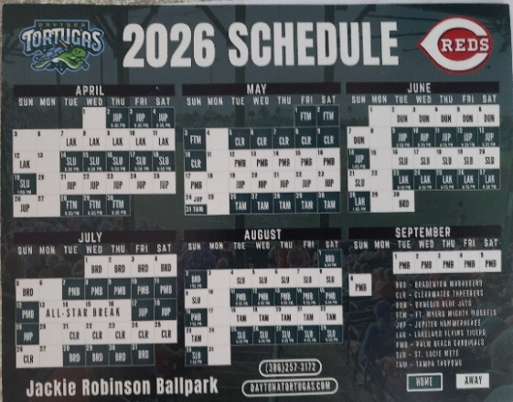  There is a copy of this schedule in the clubhouse. Tickets for the 2026 season are priced at $9 for general admission and $12 for reserved seating (including tax) or visit their website https://www.milb.com/daytona  4/17-26 Jeep Beach  4/29 Brit Floyd’s “The Moon, The Wall and Beyond” world tour honoring Pink Floyd @ Peabody Auditorium  5/7 Killer Queen, a tribute to Queen @ Peabody Auditorium  5/7-10 Welcome to Rockville @ Daytona Intl Speedway  5/16 The Magic of Motown honoring the legends of Motown @ Peabody  5/19-21 Beetlejuice, a Broadway Musical @ Peabody  6/5-6 World Racing League @ Daytona Intl Speedway  SOUNDS OF SUMMER CONCERTS Oceanfront Bandshell-7:30pm Fridays  FREE General Admission-$15 VIP  6/12 The Motowners: Motown Tribute Band  6/19 Human Clay & Jaded: Creed & Aerosmith Tributes  6/26 Rosanna & Smokin’: Toto & Boston Tributes  7/3 U.S. Bee Gees: The Bee Gees Tribute  STAR SPANGLED SUMMER CONCERTS Oceanfront Bandshell-Saturdays  7:15pm Concerts 9:45pm Fireworks  FREE General Admission-$15.00 VIP  5/23 Zendatta & Touch and Go: The Police & The Cars Tributes  5/30 Rushour & Kiss America: Rush & Kiss Tributes  6/6 Southern Cross & Bad Moon Rising: Crosby, Stills, Nash & Young & Creedence Clearwater Revival Tributes  6/13 Turnstiles: Billy Joel Tribute  6/20 Livin’ on a Prayer: Bon Jovi Tribute  6/27 Liverpool Live: The Beatles Tribute  7/4 Alter Eagles: The Eagles Tribute  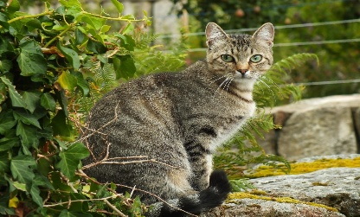  LETTER FROM A FERAL CAT  I may never be a lap cat,  or one who comes when called,  I may resist the hand that tries to touch,  And some may think I’m flawed.  I may prefer my freedom,  To your warm and cozy house,  I may reject the bowl of finest foods,  For the chance to chase a mouse.  But the box you put out for me,  Feels safe and warm and dry,  And I raise m eyes to thank you,  When I see you walking by.  And I eat the food you give me,  And I listen to your voice,  I may never be a lap cat,  But you offer me that choice.  One day I’ll see the winter,  One day I’ll see the rain,  I may grow old not knowing,  That there is freedom from this pain.  But I know you try to help me,  And although my days will end,  I may never be a lap cat,  But I know you are my friend.

